RDBMS Specification Document

Amusement Park Management System
RDBMS Schema Specification v.1.1

Submitted By: Haleema Gohar
Submitted to: Sir Ali Hassan
Subject: Database Lab
Semester: BSSE (A) – 4th Semester
Version: 1.1



INSTITUTE OF MANAGEMENT SCIENCES
HAYTABAD, PESHAWAR (2026)

Version Control Table:

Version | Milestone | Description | Status
1.0 | Project Proposal | Initial proposal of Amusement Park DBMS with problem statement, objectives, and basic planning | Completed
1.1 | Schema | Complete relational schema design, tables, keys, constraints, normalization, and SQL structure | Completed
1.2 | ERD Diagram | Entity Relationship Diagram showing table relationships and cardinality | Completed

Introduction
This technical specification document defines the complete Relational Database Management System (RDBMS) schema for the Amusement Park Management System.
- Database schema design
- Table structures
- Primary keys and foreign keys
- Constraints
- Entity relationships
- ERD diagram
The purpose of this database is to automate the management of amusement park operations such as : Customer records, Ticket purchases, Ride bookings, Ride operations tracking , Daily revenue management, Ride information management.

Entities
The amusement park database contains six major entities:
Table Name | Purpose
Customers | Stores visitor details
Tickets | Stores park entry ticket records
Rides | Stores ride information
Ride_Bookings | Stores ride usage bookings
Ride_Operations | Stores daily ride performance logs
Revenue | Stores daily earnings data

Database Schema Details

1.1 Customers Table
Stores visitiors
Column Name | Data Type | Description
customer_id | INT | Primary Key
full_name | VARCHAR(100) | Customer full name
email | VARCHAR(150) | Unique email
phone | VARCHAR(20) | Contact number
visit_date | DATE | Date of visit
ticket_type | ENUM | Adult / Child / Senior / Family

1.2 Tickets Table
Stores park entry ticket purchases.
Column Name | Data Type | Description
ticket_id | INT | Primary Key
customer_id | INT | Foreign Key
ticket_type | ENUM | Ticket category
price | DECIMAL(8,2) | Ticket price
purchase_date | DATE | Purchase date

1.3 Rides Table
Stores amusement rides information.
Column Name | Data Type | Description
ride_id | INT | Primary Key
ride_name | VARCHAR(100) | Unique ride name
ride_type | VARCHAR(50) | Ride category
min_capacity | INT | Minimum riders
max_capacity | INT | Maximum riders
price_per_round | DECIMAL(8,2) | Ride fee
status | ENUM | Active / Maintenance / Closed

1.4 Ride Bookings Table
Stores ride booking transactions.
Column Name | Data Type | Description
booking_id | INT | Primary Key
customer_id | INT | Foreign Key
ride_id | INT | Foreign Key
booked_at | DATETIME | Booking time
num_riders | INT | Number of riders
amount_paid | DECIMAL(8,2) | Amount paid

1.5 Ride Operations Table
Stores daily ride activity.
Column Name | Data Type | Description
operation_id | INT | Primary Key
ride_id | INT | Foreign Key
op_date | DATE | Operation date
total_rounds | INT | Total rounds
total_customers | INT | Customers served

1.6 Revenue Table
Stores ride earnings.
Column Name | Data Type | Description
revenue_id | INT | Primary Key
ride_id | INT | Foreign Key
rev_date | DATE | Revenue date
earnings | DECIMAL(10,2) | Daily earnings
source | ENUM | Booking / Walk-in / Group / Event

Relationships

Parent Table | Child Table | Relationship
Customers | Tickets | One to Many
Customers | Ride_Bookings | One to Many
Rides | Ride_Bookings | One to Many
Rides | Ride_Operations | One to Many
Rides | Revenue | One to Many

Constraints:

Constraint | Purpose
PRIMARY KEY | Unique row identification
FOREIGN KEY | Maintains relationships
NOT NULL | Required values
UNIQUE | Prevent duplicate values
CHECK | Validates range values
DEFAULT | Sets automatic values
ENUM | Restricts allowed text values

ERD Diagram v.1.2.

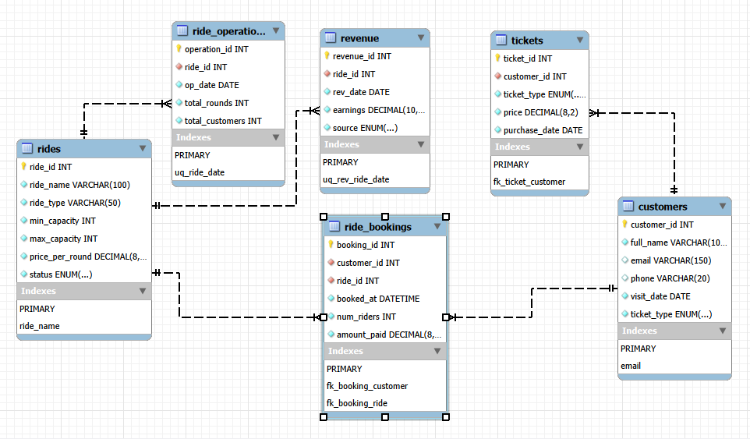

ERD Diagram Specification
The ERD diagram visually represents:
- Customers connected to Tickets
- Customers connected to Ride_Bookings
- Rides connected to Ride_Bookings
- Rides connected to Ride_Operations
- Rides connected to Revenue

Conclusion
This RDBMS schema provides an effective database solution which manages customers, rides, tickets, bookings, operations, and revenue in one integrated system for the Amusement Park Management System

